
G
HY/BI/1220A 18/11/2020
HALF YEARLY EXAMINATION (2020-21)
Subject: BIOLOGY  Grade: XII |  | Max. Marks: 70  Time: 3 Hrs
Name: |  |  | Section: | Roll No:
General Instructions: (i) All questions are compulsory. (ii) The question paper has four sections: Section A, Section B, Section C and Section D. There are 33 questions in the question paper.
Section–A has 14 questions of 1 mark each and 02 case-based questions.
Section–B has 9 questions of 2 marks each.
Section–C has 5 questions of 3 marks each and
Section–D has 3 questions of 5 marks each.
(iv) There is no overall choice. However, internal choices have been provided in some questions.
A student has to attempt only one of the alternatives in such questions.
(v) Wherever necessary, neat and properly labeled diagrams should be drawn.(CONTAINS-10PAGES)
SECTION A
1. | The immediate causes of many diseases are not infectious. Name any two such diseases. |  |  |  | 1
2. | G Diagram of components of DNA are given below. Identify and differentiate the two diagrams I and II.  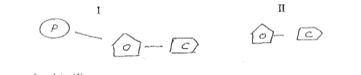 |  |  |  | 1
3. | After gel electrophoresis, DNA bands are cut out from agarose gel. What is this called as?
4. | What is criss-cross inheritance? Explain with example |  |  |  | 1
5. | Of the eight nuclei of the embryo sac in flowering plants three are at the micropylar end. How many are there at the chalazal end and how many nuclei located in the central cell? |  |  |  | 1
6. | Mention the function of non-histone protein. |  |  |  | 1
7. | Why are antibiotic resistance genes used as select able markers for E. Coli?. |  |  |  | 1
8. | Geitonogamy is functionally cross pollination, but genetically similar to autogamy. Justify the statement. |  |  |  | 1
9. | Why are proteases added while isolating the DNA? |  |  |  | 1
10. | In a young anther, a group of compactly arranged homogenous cells were observed in the center of each microsporangium. What is the name given to these cells? |  |  |  | 1
11. | Assertion: Test cross is a back cross  Reason: In test cross individual A is crossed with recessive parent  a. Both assertion and reason are true, and reason is the correct explanation  of assertion.  b. Both assertion and reason are true, but reason is not the correct explanation of assertion.  c. Assertion is true, but reason is false.  d. Both assertion and reason are false  OR  Assertion: In a monohybrid cross F1 generation indicates dominant characters.  Reason: Dominance occurs only in heterozygous state.  a. Both assertion and reason are true, and reason is the correct explanation  of assertion.  b. Both assertion and reason are true, but reason is not the correct explanation of assertion.  c. Assertion is true, but reason is false.  d. Both assertion and reason are false |  |  |  | 1
12. | Assertion: Endonucleases removes nucleotides from DNA strand.  Reason: These enzymes are required for the process of translation  a. Both assertion and reason are true, and reason is the correct explanation  of assertion.  b. Both assertion and reason are true, but reason is not the correct explanation of assertion.  c. Assertion is true, but reason is false.  d. Both assertion and reason are false.  Assertion: Genetic code is non-overlapping  Reason: No single base take part in the formation of more than one codon  a. Both assertion and reason are true, and reason is the correct explanation  of assertion.  b. Both assertion and reason are true, but reason is not the correct explanation of assertion.  c. Assertion is true, but reason is false.  d. Both assertion and reason are false. |  |  |  | 1
13. | Assertion: The first meiotic division of a primary oocyte forms two secondary oocytes that remain in this stage unless fertilization occurs.  Reason: Meiosis I result in two secondary oocytes of equal shape and size  a. Both assertion and reason are true, and reason is the correct explanation  of assertion.  b. Both assertion and reason are true, but reason is not the correct explanation of assertion.  c. Assertion is true, but reason is false.  d. Both assertion and reason are false |  |  |  | 1
14. | Assertion: Organ transplantation patients are given immunosuppressive drugs.  Reason: Transplanted tissue has antigens which stimulate the specific immune response of the recipient.  a. Both assertion and reason are true, and reason is the correct explanation  of assertion.  b. Both assertion and reason are true, but reason is not the correct explanation of assertion.  c. Assertion is true, but reason is false.  d. Both assertion and reason are false |  |  |  | 1
15.  i)  ii)  iii)  iv)  v) | Read the following and answer any four questions from 15(i) to 15(v) given below:  Novel pandemic coronavirus (SARS CoV-2) was first reported in Asia in late 2019 and has spread rapidly and indiscriminately worldwide. Its full range of impacts will far exceed those resulting from the disease itself.  The environment is an important moderator of the spread of COVID-19, and natural resources may also help mitigate the economic impacts of the global response to coronavirus. With nature itself being the largest source of microbes that could become novel human pathogens, such wide ranging, intersectoral and potentially transformational impacts make pandemic emergencies of central relevance to the emerging field of planetary health.  A vaccine stimulates your immune system to produce antibodies, like it would if you were exposed to the virus. Passive immunity can be conferred directly by  (a) vaccines  (b) antitoxins  (c) colostrum  (d) both (b) & (c)  The substance produced by a cell in viral infection that can protect other cells from further infection is  (a) serotonin  (b) colostrum  (c) interferon  (d) histamine.  Which organs are most affected by viruses mostly?  (a) The upper respiratory tract (sinuses, nose, and throat)  (b) The lower respiratory tract (windpipe and lungs).  (c) Both a&b  (d). Arteries and veins  Two groups of people are at a higher risk of getting severe COVID-19 disease. These are  (a). Older people  (b). Those with underlying medical conditions.  (c) Both a &b  (d). Only b  Which of the following factors affect human health?  (i) Infections  (ii) Silent mutation  (iii) Lifestyle  (iv) Genetic disorders  (a) (i), (ii)and(iv)  (b) (i) and (ii)  (c) (i), (iii) and (iv)  (d) (i), (ii), (iii) and (iv) |  |  |  | 4
16.  i)  ii)  iii)  iv) | Read the following and answer any four questions from 16(i) to 16(v) given below:  Many non-living substances such as fluids, hormones, and pheromones are also important accessories to the reproductive system. Unlike most organ systems, the sexes of differentiated species often have significant differences. These differences allow for a combination of genetic material between two individuals, which allows for the possibility of greater genetic fitness of the offspring. In mammals, the major organs of the reproductive system include the external genitalia as well as a number of internal organs including the gamete producing gonads.  There are some special types of cells present in the seminiferous tubules of male reproductive system known as Sertoli cells which are  (a) somatic cells  (b) germinal cells  (c) protective cells  (d) reproductive cells  Which of the following is not the purpose of seminal fluid?  (a) fertilizing ability  (b) motility  (c) ovulation  (d) transportation  Another name for Bulbourethral gland is  (a) perineal gland  (b) Prostate gland  (c) urethral gland  (d) Cowper’s gland  Which hormone is responsible for the development of male secondary sexual characters?  Which of these is a role of oestrogen?  (a)It maintains the lining of the uterus during the middle part of the menstrual cycle  (b) It repairs and thickens the lining of the uterus  (c) It triggers the release of a mature egg  (d)It triggers the release of a mature egg |  |  |  | 4
 | SECTION B
17. | Lymph nodes are secondary lymphoid organs. Describe the role of lymph nodes in our immune response.  G |  |  |  | 2
18. | Gi Expand VNTR and describe its role in DNA Fingerprinting |  |  |  | 2
19. | Observe the diagram and answer the questions:  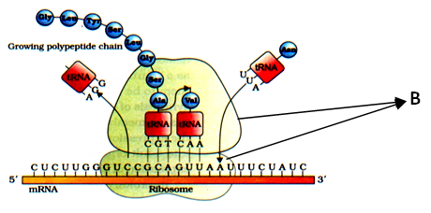  a. a) Identify the process shown in the figure and define it.  b. b) Identify the structure B. Write any one function of it in the process shown in the diagram. |  |  |  | 2
20. | Use of a thermostable DNA polymerase from the bacterium, Thermus aquaticus, made it possible to generate billion copies of DNA in a very short time using a process.  a. a) Name the process  b. b) Name the three important steps involved in this process.  OR  . A bacterial cell is shown in the figure given below. Label the part ‘A’ and ‘B’. Also mention the use of part ‘A’ in rDNA technology.  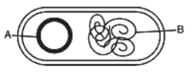 |  |  |  | 2
21. | In the given figure of a dicot embryo, label the parts (A) and (B) and give their function.  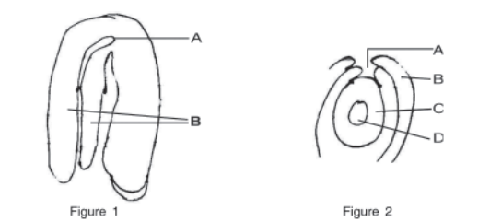  OR  Among the animal, insects particularly bees are the dominant pollinating agents. List any four characteristic features of the insect pollinated flower. |  |  |  | 2
22. | The diagram given below shows the transverse section of a young anther. Identify the parts a, b, c and d.  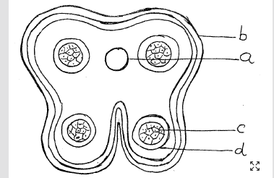  OR  Mark the following in the picture given below:  a. Hilum b. Funicle c. Nucellus d. Chalazal pole  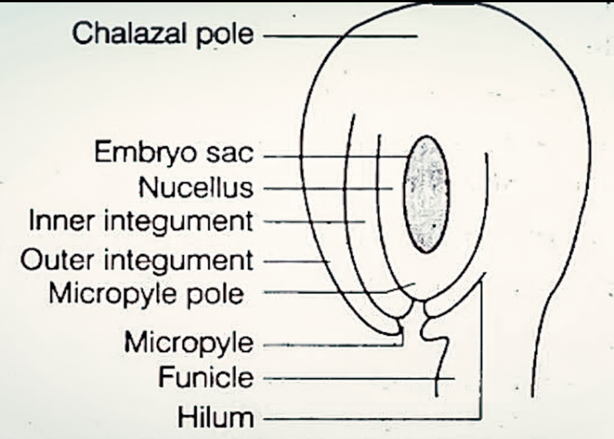  . |  |  |  | 2
23. | The following photograph shows the result of a technique showing the separation of DNA.  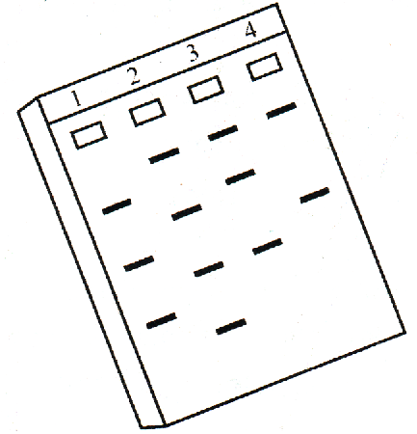  - Name the technique.  - How the separated DNA is visualized?  - DNA fragments of size 500 bp, 1600 bp and 2000 bp are separated by this process. Which fragment will migrate fast? Why? |  |  |  | 2
24. | Outer envelope of pollen grain made of a highly resistant substance. What is that substance? At which particular point the substance is not present? |  |  |  | 2
25. | What are Cry proteins? Name an organism that produce it. How has man exploited this protein to his benefit? |  |  |  | 2
 | SECTION C
26. | A Selectable marker is used in the section of recombinants on the basis of their ability to produce colour in presence of chromogenic substrate.  (a) a) Mention the name of mechanism involved.  b) Which enzyme is involved in production of colour?  ( c) How is it advantageous over using antibiotic resistant gene as a selectable marker?  (a |  |  |  | 3
27. | Po Polypeptide chains of two hemoglobin molecules are shown below. One of the chains shows an abnormality. Observe the diagram and answer the following questions.  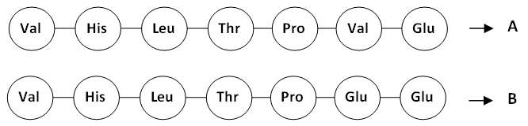  a. a. Which of the polypeptide chain of the hemoglobin is abnormal leading to a disease?  b. b. What is the reason for this abnormality?  c. c. What will be the effect of this change in polypeptide chain? a |  |  |  | 3
28. | Observe the given sequence of nitrogenous bases on a DNA fragment and answer the following question – 5´ – CAGAATTCTTA – 3´ 3´ – GTCTTAAGAAT – 5´  (a) Name a restriction enzme which can recognise this DNA sequence.  (b) Write the sequence after digestion.  (c) Why are the ends generated after digestion called sticky ends? |  |  |  | 3
29. | Flowering plants evolved an array of adaptations to achieve pollination.  a. Explain pollination.  b. Point out adaptations found in flowers for insect pollination and wind pollination.  c. Illustrate pollination in Vallisnaria i) |  |  |  | 3
30. | In a bacterial culture, some of the colonies produced blue color in the presence of a chromogenic substrate and some did not due to the presence or absence of an insert (r DNA) in the coding sequence of (3 – galactosidase).  (a) Mention the mechanism and the steps involved in the above experiment.  (b) How is it advantageous over simultaneous plating on two plates having different antibiotics.  OR  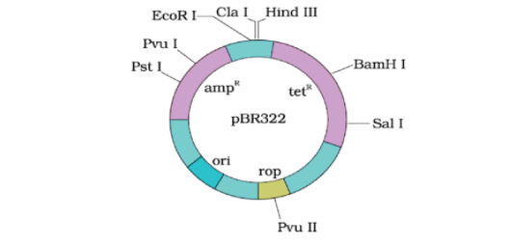  The above picture shows cloning vector pBR³²².  a. What is ori? Give its importance.  b. How does the insertion of foreign DNA at Bam HI site selected?  c. How many cloning sites are depicted in this vector as shown in the figure? |  |  |  | 3
 | SECTION D
31. | A tall plant with red flowers (dominant) is crossed with a dwarf plant with white flowers (recessive). Work out a dihybrid cross and state the dihybrid ratio. What will be the effect on the dihybrid ratio if the two genes are interacting with each other?  OR  a) Distinguish between Mendelian disorder and chromosomal disorder.  b) By taking starch synthesis in pea seeds as an example, explain how a single gene product may produce more than one effect. |  |  |  | 5
32. | In E. coli, lactose catabolism is controlled by Lac operon. Lac operon in the absence of inducer (lactose) is given below:  a. What is ‘P’? (½)  b. Name the enzymes produced by the structural genes ‘Z’, ‘Y’ & ‘a’. (1½)  c. Redraw the diagram in the presence of an inducer. (1)  d. Explain the process of metabolism if both glucose and lactose are present. (2)  OR  i)Write the specific features of the genetic code AUG.  (ii) Genetic codes can be universal and degenerate. Write about them, giving one example of each.  (iii) Explain aminoacylation of the tRNA. |  |  |  | 5
33. | 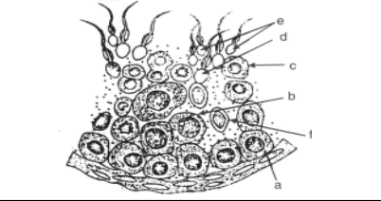  Study the figure given:  (i) Pick out and name the cells that undergo spermiogenesis.  (ii) Name ‘A’ and ‘C’ cells.  (iii) Give ploidy of ‘B’ and ‘E’  (iv) What are the cells marked as ‘F’? Mention their function.  (v) Mention the type of cell division in A and B. |  |  |  | 5
***

